User Guide

Form Scriber Mobile Application

University of Maryland Global Campus

March 30, 2021

Version 1

Presented by: Sylvia Lopez, Karim Mansour, Alex Dattilio, Bertina Lee, Brian Malott, Komi Noukafou, Joselito Ocampo, Ermias Seyoum, Arnaud Tako

Table of Contents

1 General Information 5

1.1 Introduction 5

1.2 Overview 5

1.3 List of Abbreviations/Acronyms 5

2 Software Description 5

2.1 Features 5

3 Connections to the Application 6

4 Software Specifications 6

5 Hardware Specifications 6

6 App Pages 6

6.1 Landing Page 6

6.1 Login Page 7

6.2 Menu 7

6.3 Home Page 10

6.4 Begin Conversation 10

6.5 View Reports 14

6.6 Settings 14

6.7 Help Page 15

6.8 Log out 20

7. Troubleshooting 21

Disclaimer and Warranties

Form Scriber mobile application comes with no warranty. This software is free to use by anyone. It comes with no warranties and is provided solely “AS-IS”. It may contain significant bugs, or may not even perform the intended tasks, or fail to be fit for any purpose. University of Maryland is not responsible for any short comings and the user is solely responsible for the use.

# 1 General Information

## 1.1 Introduction

This document serves as a guide for all users of the Form Scriber mobile application. This User Guide will assist in navigating through all of the application features, and troubleshooting any issues that might be encountered. The guide will go over the connection to the application, and software specifications.

## 1.2 Overview

The Form Scriber mobile application will allow an interviewer to fill out a form one field at a time through voice recording. Once the form is confirmed to be completed, the document will be available in your Google Drive account for access.

## 1.3 List of Abbreviations/Acronyms

|  |  |
| --- | --- |
| Acronyms and Abbreviations | Definitions |
| IDE | Integrated Development Environment |
| iOS | iPhone Operating System |
| API | Application Programming Interface |
| App | Application |

# 2 Software Description

Form Scriber is a dynamic mobile app used to create customized form reports. After a form is created by the professional, the Form Scriber app records the user and their client's conversation. The form is then automatically filled out by the system, and a formal report is generated. The report can be saved on the mobile device and printed as a physical document.

2.1 Features

* **Usability:** Form Scriber can be used in multiple settings where interviews take place using a mobile device.
* **Efficiency and time-saving:** The User Interface is designed for ease of use for logging in and a simple button to press to start and stop the recordings. The sliding screen makes it easy to access the menu options. Report forms can be saved and printed quickly.
* **Invaluable** - Form Scriber allows professionals to spend quality time with their clients by taking out the burden of hands-on documentation.

# 3 Connections to the Application

The Form Scriber application requires a Google account to log in to the system. You should use a Gmail account from Google for a username and password that exists or sign-up for a new account to login into the Form Scriber application. Once you provide your Gmail credentials, it will pass through multiple processes for authentication to log in to the application.

# 4 Software Specifications

This mobile application has been built with Android Studio IDE which includes the package for Android and iOS devices. Some proper configurations have been made for the application to work on both Android and iOS devices. The Form Scriber application has been built with the latest framework updates. For this matter, the testing results using API 29 and 30 show that it will work on all recent versions, such as Android 10 and above and iOS 13 and above.

5 Hardware Specifications

6 App Pages

## 6.1 Landing Page

A Landing Page will open consisting of two buttons Log In and Help. When pressed the Log In button will redirect you to the Login page, and when the Help button it pressed it will redirect you to the Help page.

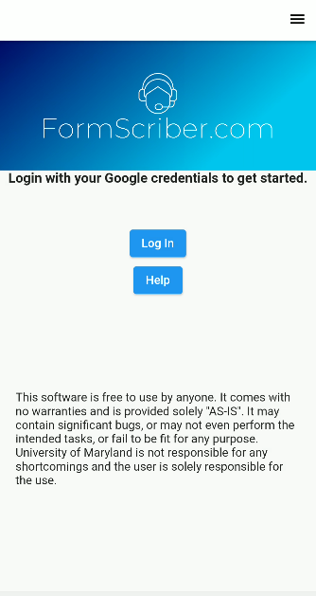

## 6.1 Login Page

The user will sign in using their Google account after clicking on the Log In button. Choose an account to sign in the app. The User can sign out of the app by clicking the Log Out button on the sliding screen.

## 6.2 Menu

The menu can be accessed by either tapping on the icon (Figure 6.2a) in the upper right corner or sliding a finger right to left from any screen. This will present a menu (Figure 6.2b) from which other areas of the application are accessed.

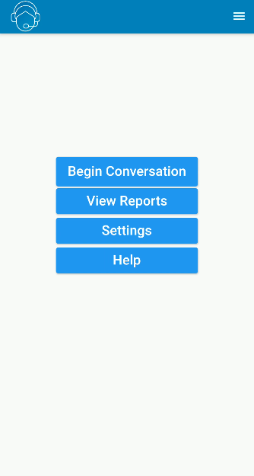

*Figure 6.2a - Menu icon*

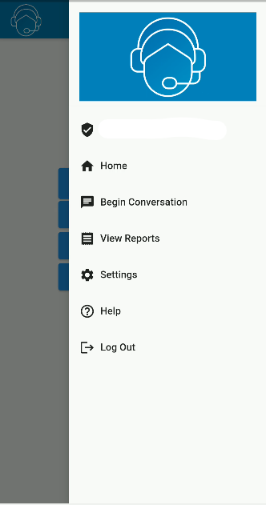

*Figure 6.2b - Menu displayed*

|  |  |
| --- | --- |
| Menu Item | Section of the application |
| Landing Page | Redirects to the Login page, or the Help page (Section 6.1) |
| Home | Redirects to the Home page (Section 6.3) |
| Begin Conversation | Redirects to the Begin Conversation page (Section 6.4) |
| View Reports | Redirects to the View Reports screen (Section 6.5) |
| Settings | Redirects to the Settings screen (Section 6.6) |
| Help | Redirects to the Help screen (Section 6.7) |
| Log out | Logs out of the application (Section 6.8) |

## 6.3 Home Page

From the Home page (Figure 6.3), you can begin a conversation with the chat bot, view reports, modify settings and access help.



*Figure 6.3 - Home page*

## 6.4 Begin Conversation

Upon initial access to the Begin Conversation screen, you are prompted to select your desired form to work with (Figure 6.4a).

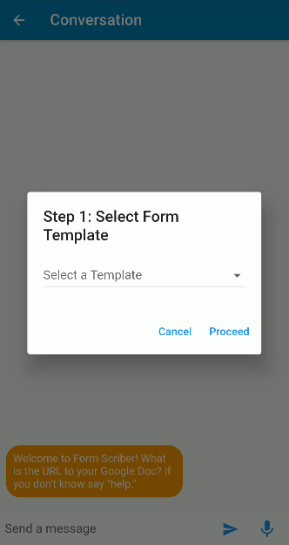

*Figure 6.4a - Prompt for form selection*

After clicking on *Proceed*, you are taken to the chat screen (Figure 6.4b).

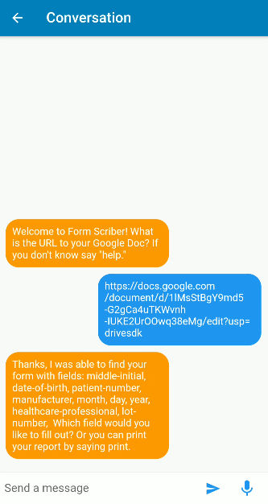

*Figure 6.4b - Chat screen*

After selecting a form template, the user can begin speaking to Form Scriber by tapping the Microphone button.



*Figure 6.4c - Tapped Microphone button*

Upon completion of a report, the user can say “print” to get a URL of their completed report.

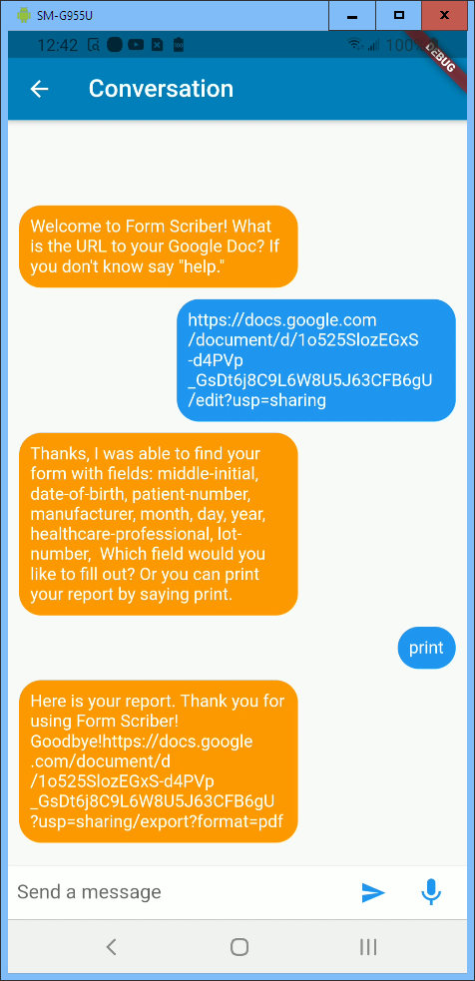

*Figure 6.4d - Completed Report Link*

## 6.5 View Reports

Any reports that you have generated will be accessible on this page.

## 6.6 Settings

There are some settings that you may modify for the application. You may click on the Settings button on the Home page (Figure 6.6a) to enter the settings. On the settings page, you may set the Google Drive path to save your reports (Figure 6.6b). Another setting is the font selector (Figure 6.6c). You may select from the menu of fonts. You may also change the font size from the menu of sizes (Figure 6.6d). You may also select or deselect the checkbox to enable or disable dark mode, which will reverse the contrast of the display of the application (Figure 6.6d).

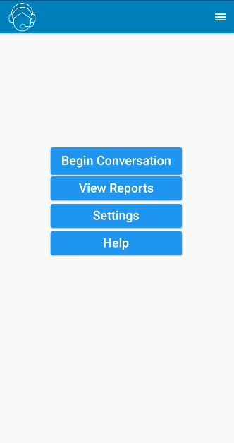

*Figure 6.6a Settings button on Home page*

## 6.7 Help Page

The Help page feature displays when you are logged into the application. You may click on the Help button on the Home page (Figure 6.3a), Landing page or select the Help item from the sliding menu (Figure 6.3c) to view essential articles that guide how to use the “Form Scriber” application. Below are screenshots which show how the Help page displays the essential articles.



*Figure 6.3a - Help button on Home page*



*Figure 6.3c - Help link on the sliding menu*

Tapping the Help button on the Home page or the Landing page opens a new screen with the Help article as shown in Figure 6.3d.

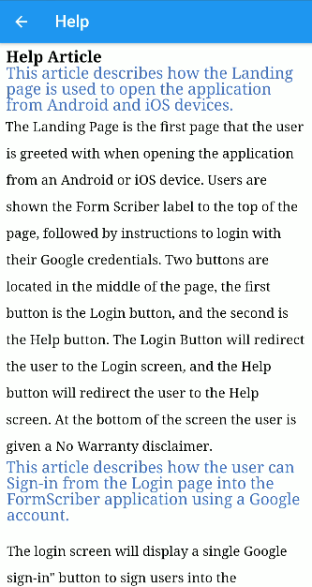

*Figure 6.3d - Help article from Landing page*

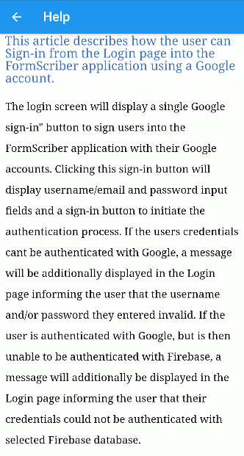

*Figure 6.3e - Help article from Sign-in page*

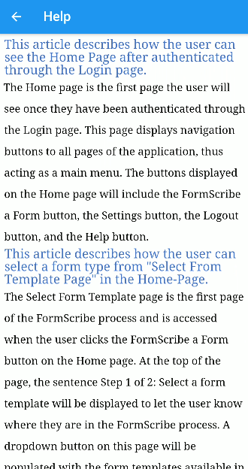

*Figure 6.3f - Help article from Home page*

## 6.8 Log out

To log out of the application, tap the Log Out menu item from the sliding menu (Figure 6.8). This will clear your session and redirect you to the landing page of the application.



*Figure 6.8 - Log Out option from the sliding menu*

7. Troubleshooting

Issues Logging into the application - If not able to login in, make sure you are logging in with your Google email, and password. Any other email provider will not work.

Not able to access my recorded form – Navigate to your Google Drive that is connected to the Google account credentials that you logged in with.

Recording is not working – Make sure your microphone is on, and you have allowed the app access to your microphone. This can be done through your phone settings.